## Assignment -4

Python Programming

|  |  |
| --- | --- |
| Assignment Date | 19 September 2022 |
| Student Name | Ms. Subasri.D.R |
| Student Roll Number | 820419104073 |
| Maximum Marks | 2 Marks |

**Question-1:**

# Write a python program to test a given number is prime or not

|  |
| --- |
| **Solution:** |
| num = int(input("enter the number you want to test as prime or not : ")) if num > 1:  for i in range(2, int(num/2)+1): if (num % i) == 0:  print(num, "is not a prime number") break  else:  print(num, "is a prime number")  else:  print(num, "is not a prime number") |
|  |

**Question-2:**

# write a program to generate odd numbers from m to n using while loop.

|  |
| --- |
| **Solution:** |
| minimum = int(input(" enter m minimum value:")) maximum = int(input(" enter n maximum value: ")) X=1;  if (minimum < maximum):  while X in range(minimum,maximum + 1): if( X % 2 != 0):  print("{0}".format(X)) X=X+1;  else:  print("Minimum value must be less than maximum value") |

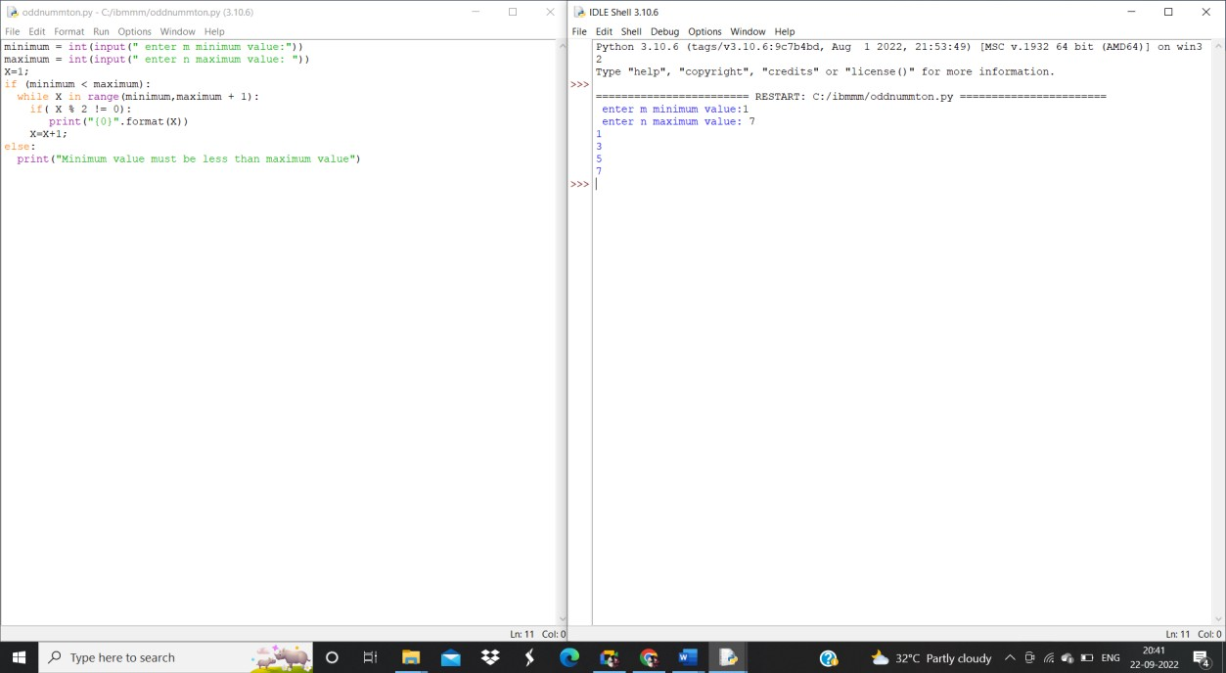

## Question-3:

Write a python program to display prime number series upto a given number

## Solution:

upper_value = int(input ("Please, Enter the Upper Range Value: "))

number=1

print ("The Prime Numbers in the range are: ") for number in range (number,upper_value + 1):

if number > 1:

for i in range (2, number):

if (number % i) == 0: break

else:

print (number)

## output:

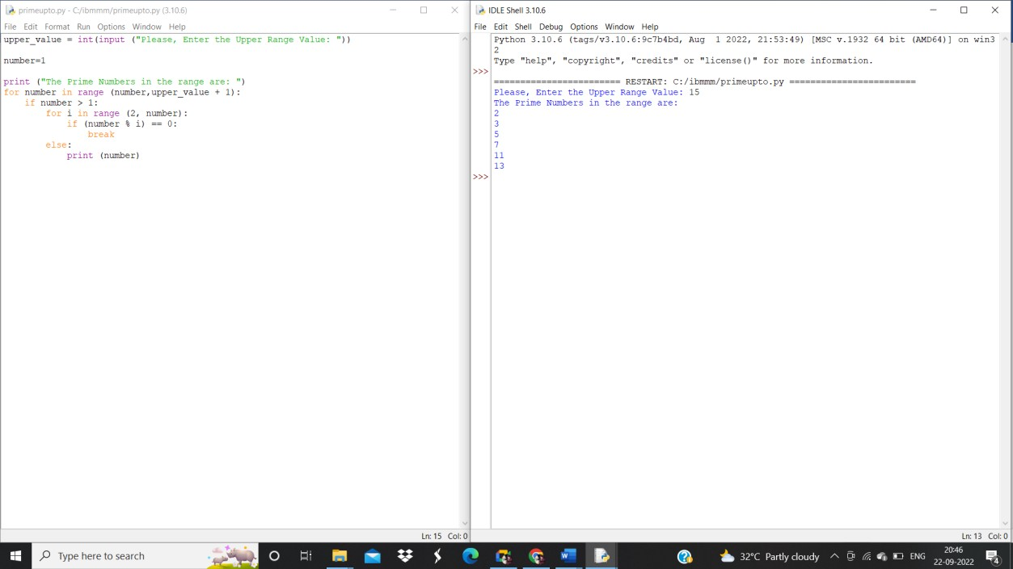

**Question-4:**

Write a python program to generate Fibonacci series

## Solution:

n_terms = int(input ("How many terms the user wants to print? "))

n_1 = 0

n_2 = 1

count = 0

if n_terms <= 0:

print ("Please enter a positive integer, the given number is not valid") elif n_terms == 1:

print ("The Fibonacci sequence of the numbers up to", n_terms, ": ") print(n_1)

else:

print ("The fibonacci sequence of the numbers is:") while count < n_terms:

print(n_1)

nth = n_1 + n_2 n_1 = n_2

n_2 = nth count += 1

